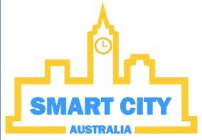Mock-Up of Student Homepage

Colleges

Smart City

City Information

Libraries

Colleges

Log Out

Mock-Up of Businessman Homepage

Smart City

Log Out

Hotels

Industries

City Information

Industries

Mock-Up of Tourist Homepage

City Information

Hotels

Tourist Destinations

Smart City

Log Out

City Information